Name : Tushar Pathak
Reg Num : 230905396
Roll Num : 6CSEB-B2

Week 9 : Form Processing using Django – Part II

Q1)Create a Register page and Success page with the following requirements:
i.Register page should contain four input TextBoxes for UserName, Password,
Email id and Contact Number and also a button to submit. Make the username as
compulsory field and other fields as optional.
ii.On button click, Success page is displayed with message "Welcome
{UserName}" and also his Email and Contact Number has to be displayed.
iii. Use secure technique to send details to the Success page (Hint: use csrftoken) 4)
Design a website with two pages.
Output :
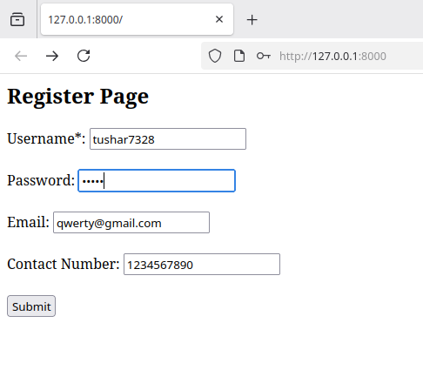
Register Page

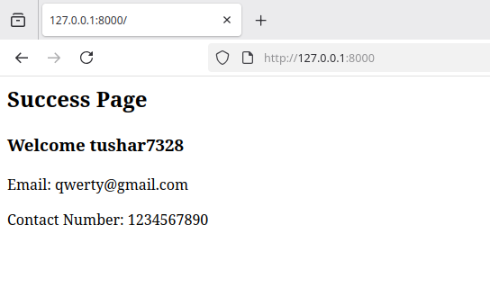
Success Page
Q2)“How is the book ASP.NET with c# by Vipul Prakashan?” Give the user three choice : i) Good
ii) Satisfactory iii) Bad. Provide a VOTE button. After user votes, present the result in
percentage using labels next to the choices
Output:
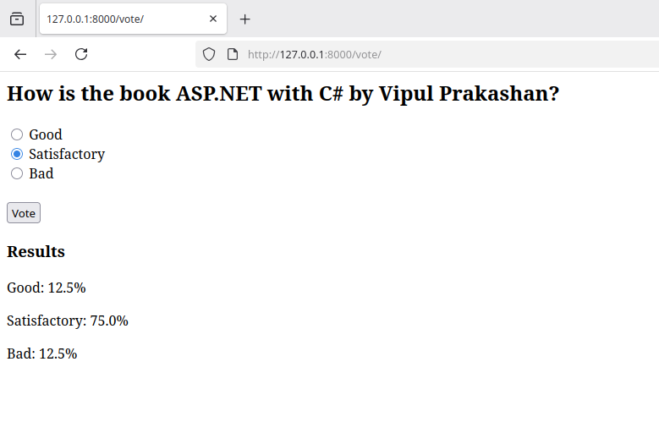
Voting Page
https req and res
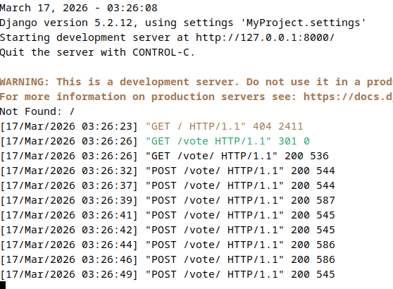

Q3) Create a website with two pages. Page 1 has two TextBoxes (name and total marks)
and one ‘Calculate’ Button as shown in the figure. On clicking the ‘Calculate’ Button,
CGPA (total marks/50) along with the name should be displayed in the Page 2. Use
Django sessions to store the information.
Output:

Page 1

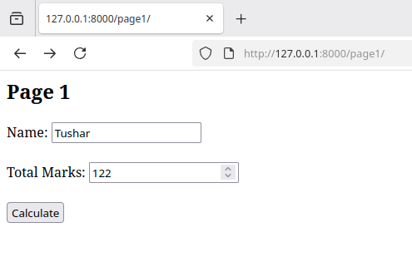

Page 2
